ServiceNow Agent Configuration Guide (v1.1.0.3)
Already have a ServiceNow Developer instance? Skip to Power Platform Environment Preparation.

ServiceNow Demo Environment Provisioning
Developer.servicenow.com
Create an account and login
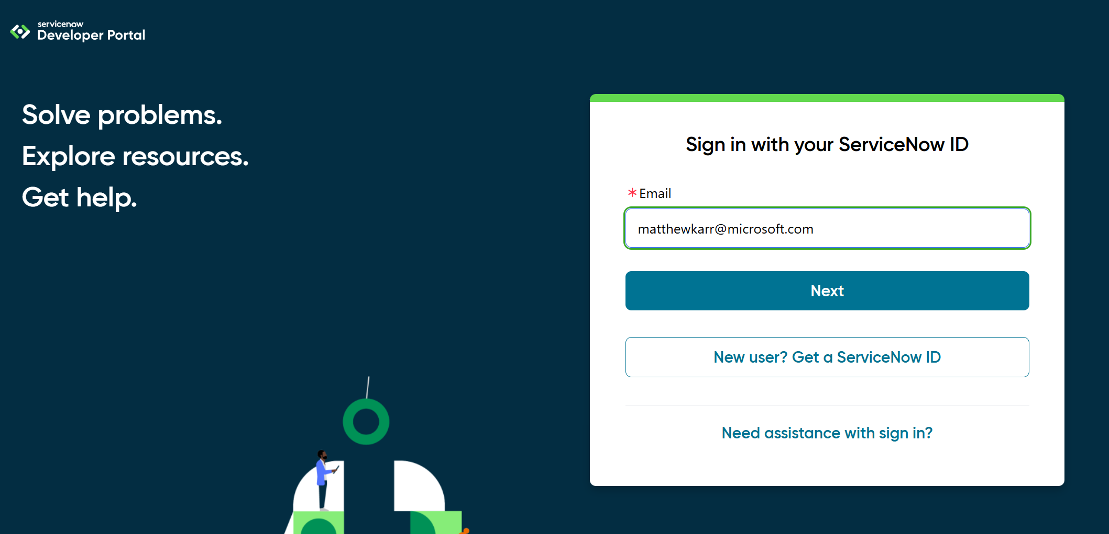

On first login, click to have it provision an environment. ServiceNow is generous with their demo environments, but you do have to interact frequently to keep it.

Click the drop down at the top right under your profile icon. And look for a button labelled, “Manage my instance.”
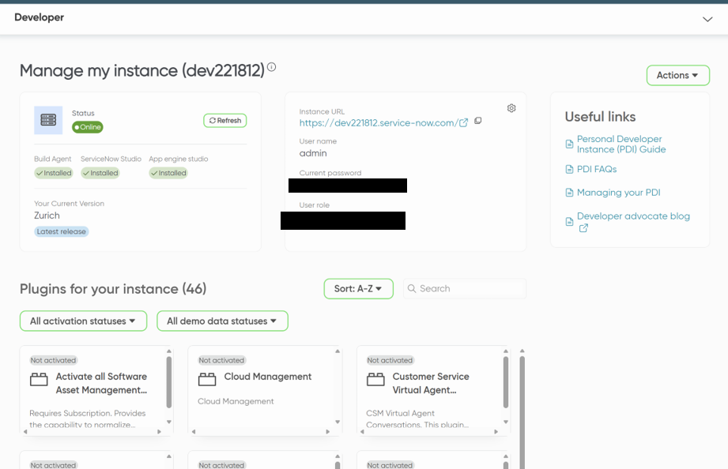

In this space you will see details about your instance. This is where you will also see your login information needed to establish connections from your agent. You will only need the first part of the URL for the connection. In the above screenshot, I would only need dev221812. After a few days away, this would also be where you click a button the “wake my instance,” which is necessary for our agent to work.

Hit the dropdown again and click “Start Building.”
Click All in the top left corner next to the logo
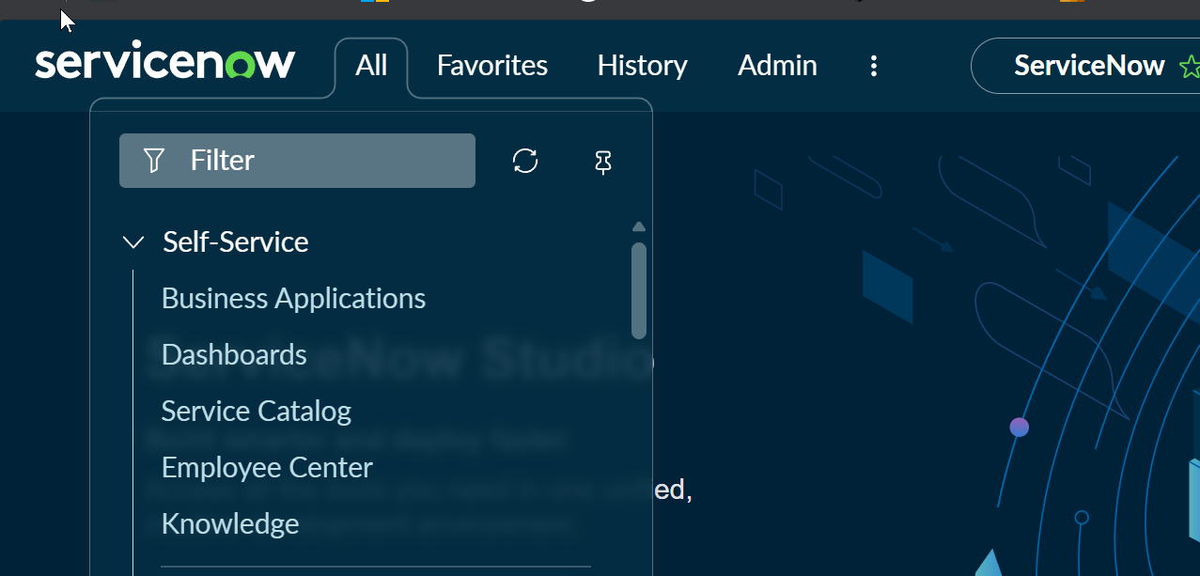

Search “incidents” and select the option under Service Desk NOT Self-Service
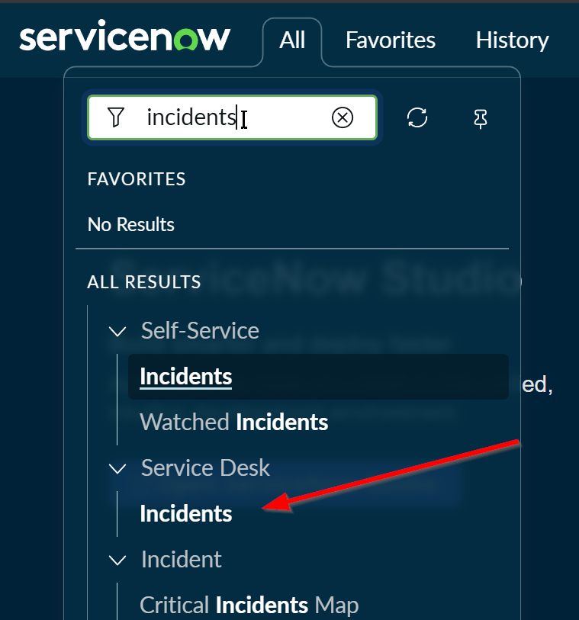

Here you will find the incidents list that Service Desk techs work with and will be necessary to verify your agents ability to open and recall tickets.
Let’s do another search for Knowledge.
Select the Knowledge option under Service Desk. Then select IT under Knowledge Bases.
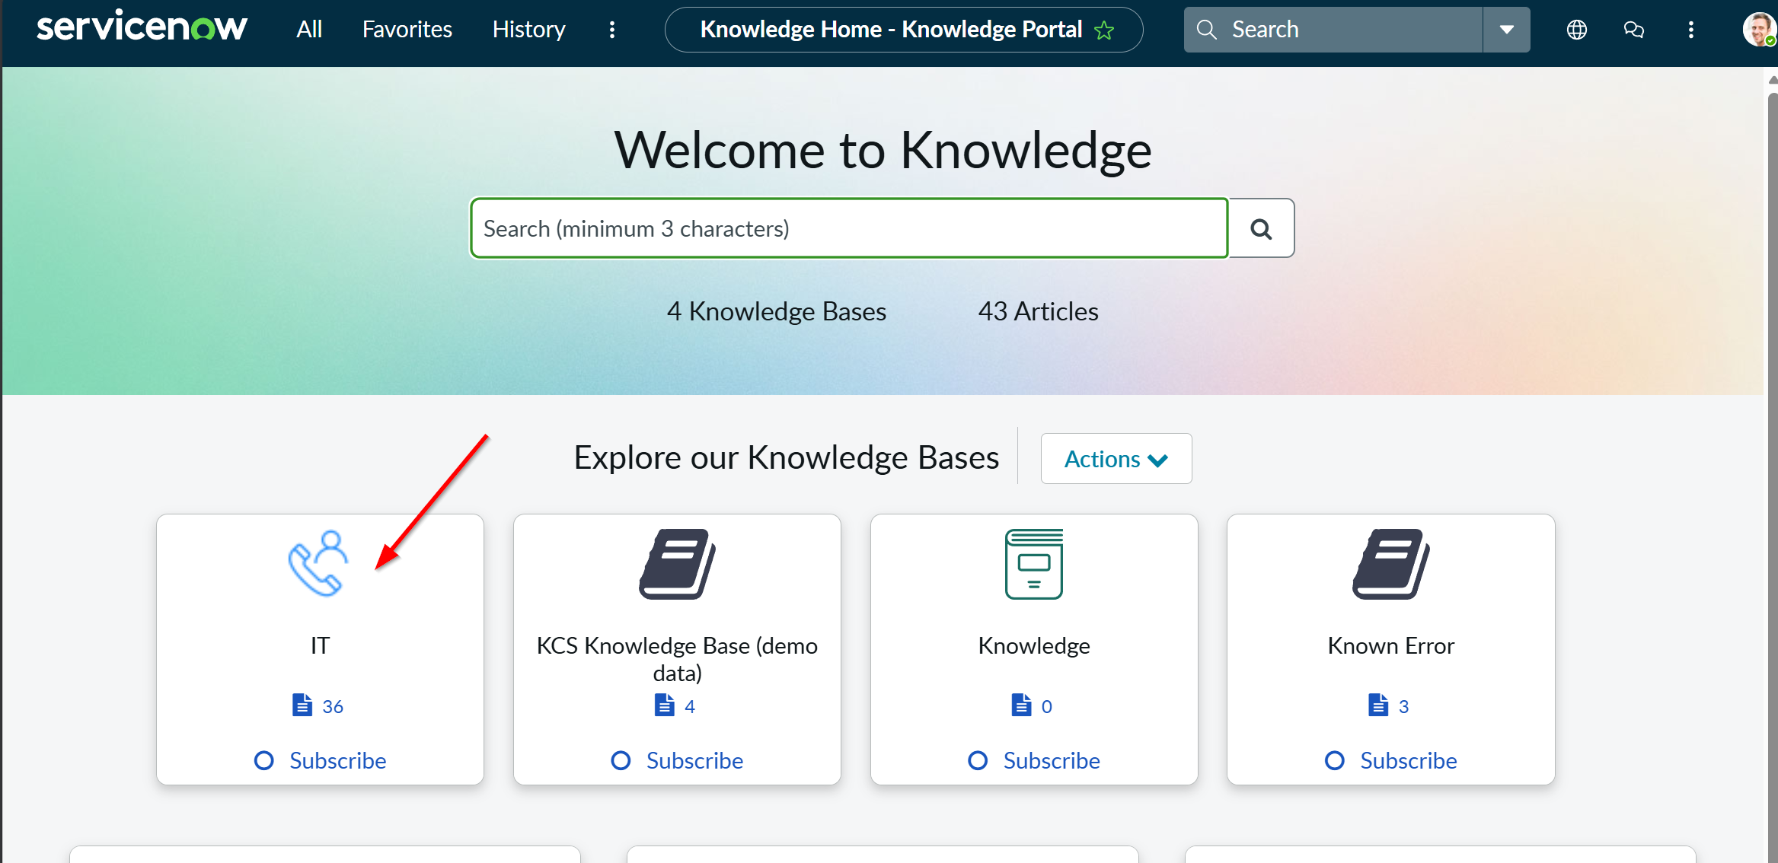

Here we can see the list of provisioned KBs. We will use these to develop test questions for the knowledge capabilities of our agent.
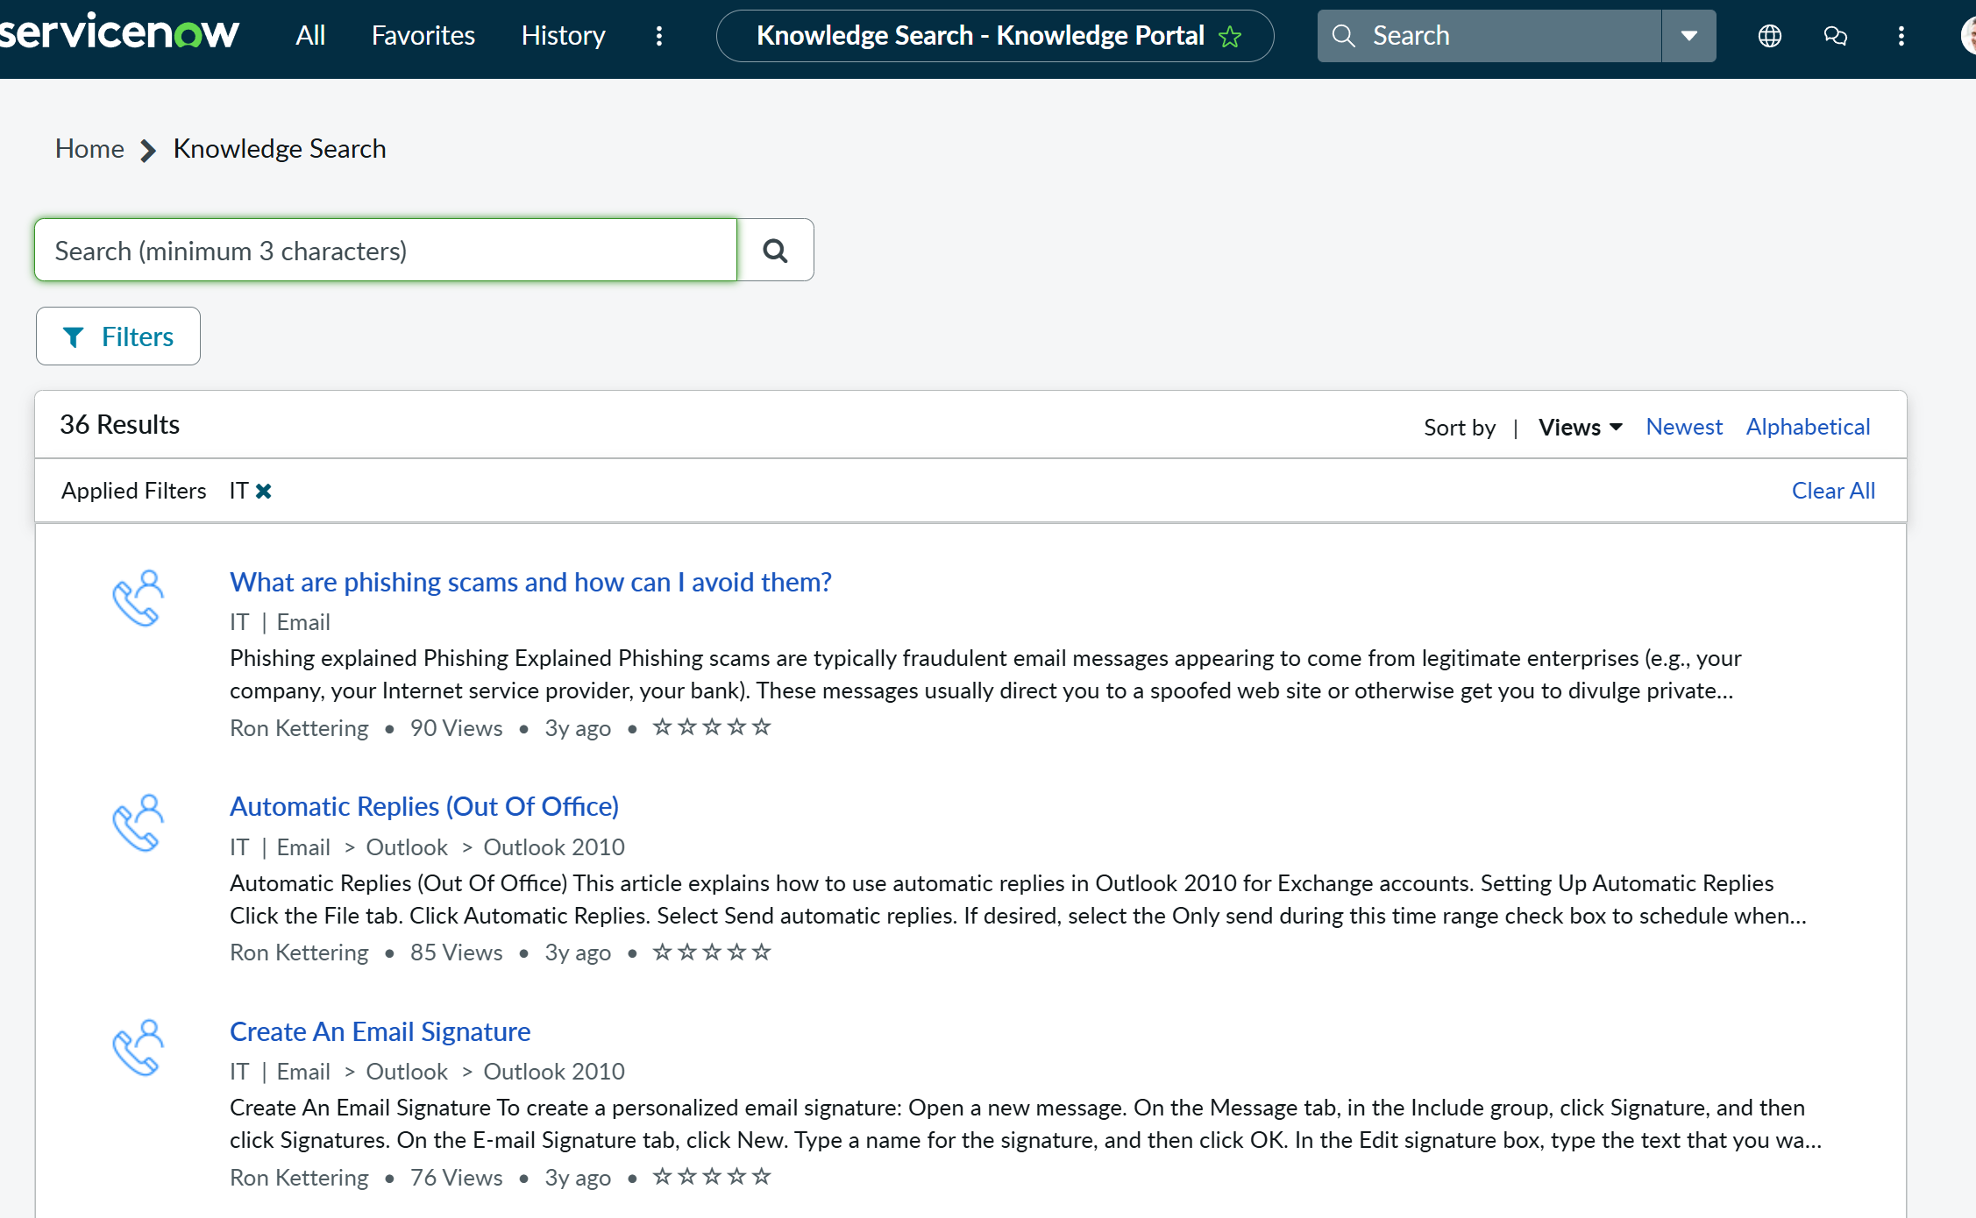

Next, we’ll create and configure the agent in Copilot Studio.

Power Platform Environment Preparation

First we need to prep our environment by establishing a connection to ServiceNow.
**The target environment must have a Dataverse Data store. This will be required to install the solution as well as the indexed knowledge articles.**
From make.powerapps.com
Make sure you are in the correct environment where your demo agent will live. It is strongly encouraged that you do not deploy this to Default or Personal Productivity.
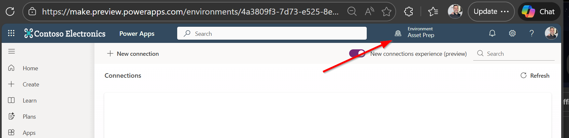

Next, select connections from the left navigation menu. You may need to click on more to see this option.
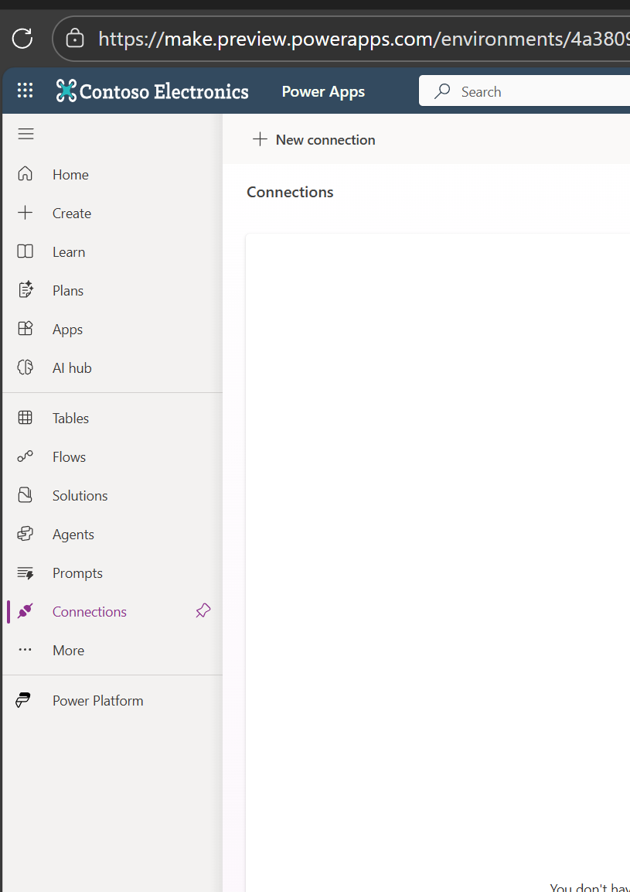
Click Create connection.
In the top right (not top center) search for ServiceNow.
Click the plus sign under the action column.
Populate the information for your demo space. Be sure to choose basic authentication.
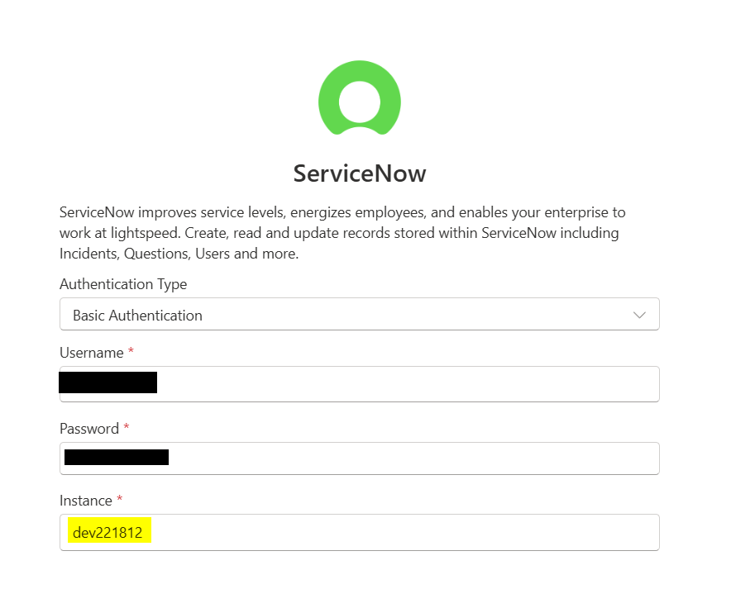
Then click create
You should see your new connection in the list with a status of “Connected.”
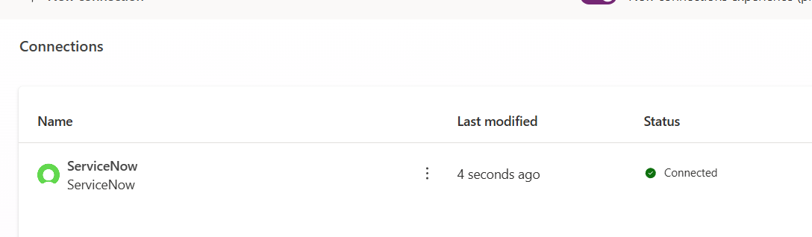

ServiceNow Agent Import
Lets install our solution
On the left navigation, where we previously selected connection, now select “Solutions.”
Select Import solution from the top navigation ribbon.
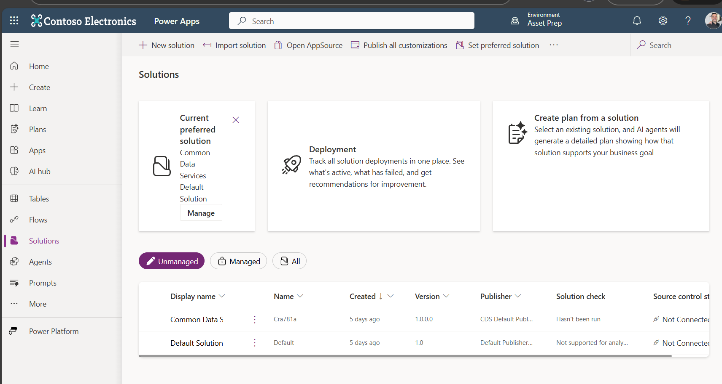
Browse to the location where you have stored the zipped solution file and select it.
Select Next. The wizard will do a bit of processing.
On the details screen select next.
On the Connections page, you should see one row processing. After a moment, a green checkmark appears on the right. Select the three dots for that row and verify it is using the ServiceNow connection you created earlier.
Click Import
A new ribbon will appear below the ribbon where we first initiated the import. After about 30 seconds the bar will turn green if the import was successful.
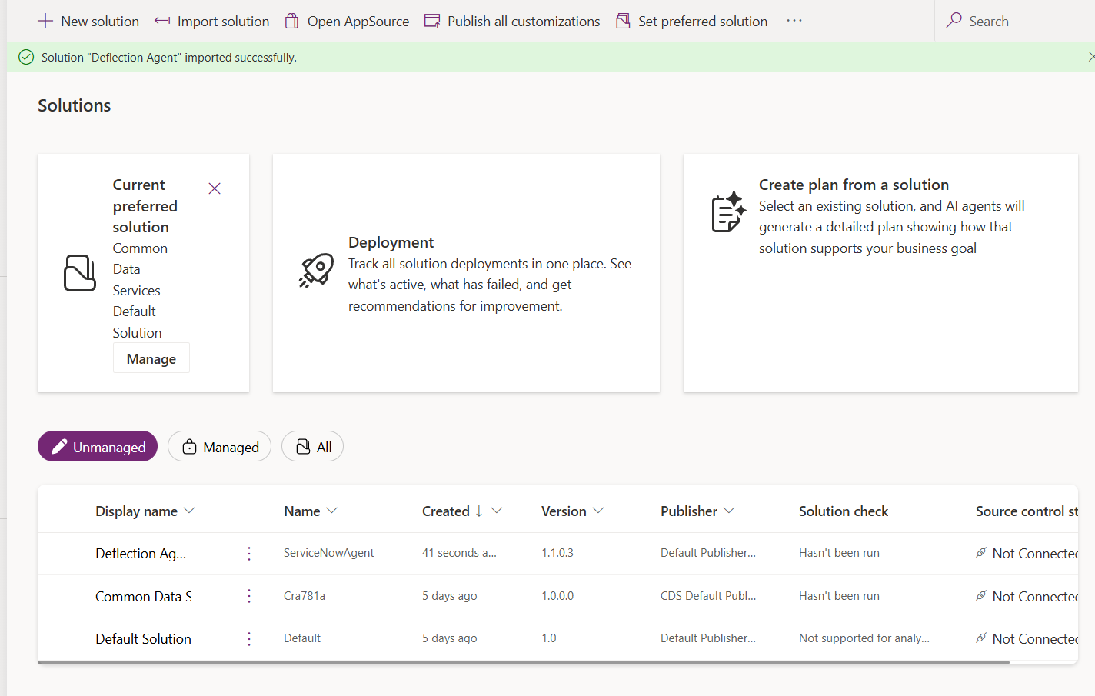
We now see the new solution in the list for this environment.
Open that solution by clicking on the display name.
Select agent from the solution object manifest
Click on the display name of the agent.
We will now begin configuring our agent.

ServiceNow Agent Configuration

Overview
Verify that the agent description and instructions are populated. The description may be modified it will be part of a larger agent to agent build.
Modify the first paragraph in the agent instructions to influence it’s persona and tone.
Be sure to save your changes before moving on to the knowledge tab

Knowledge
On the knowledge tab, select Add Knowledge
Select ServiceNow. If the button is not visible you are able to search for it in the top search bar.
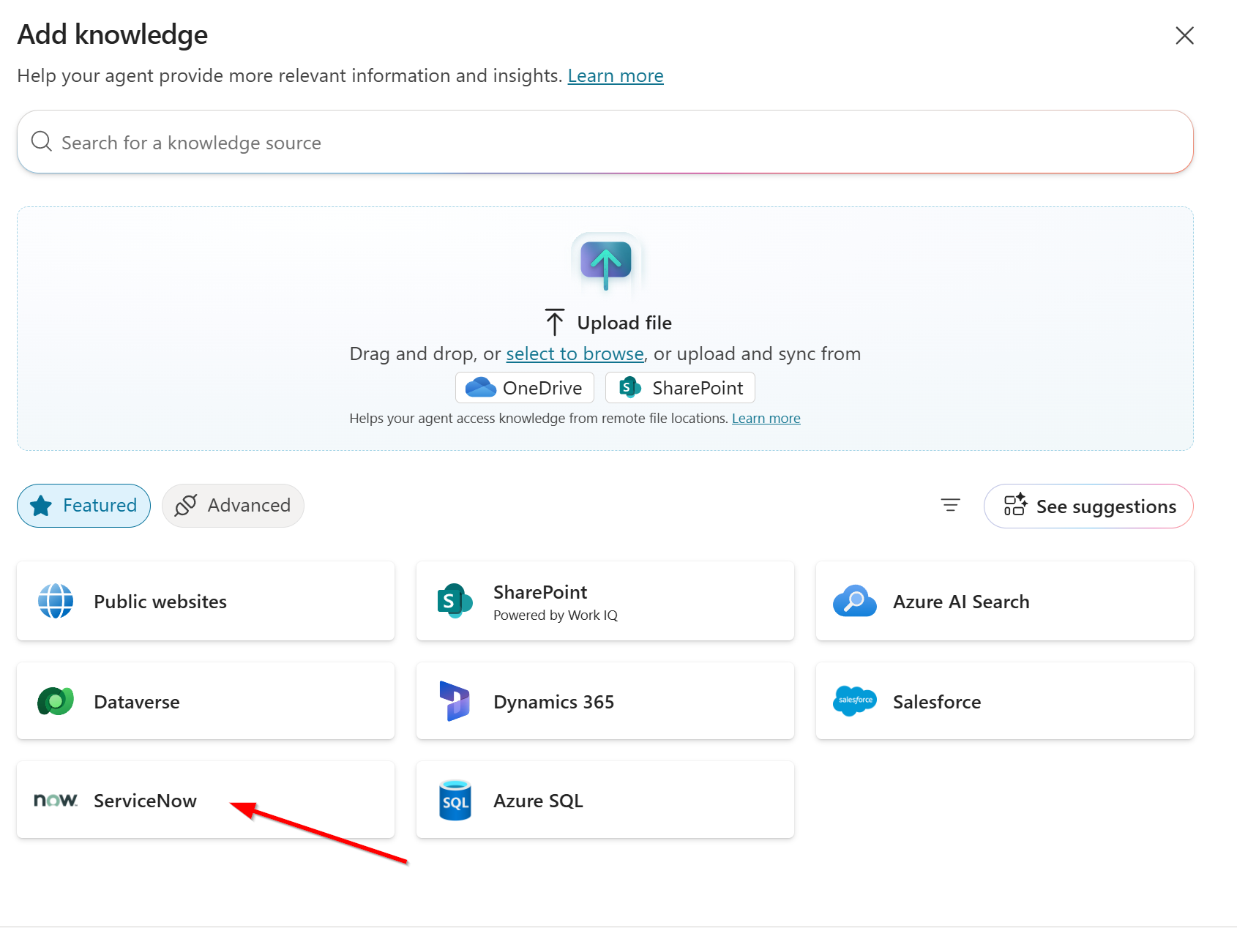

The knowledge source should automatically select your ServiceNow connection. If needed, open the connection dropdown and select the connection you created.
Check the box on the row listed as “Knowledge.”

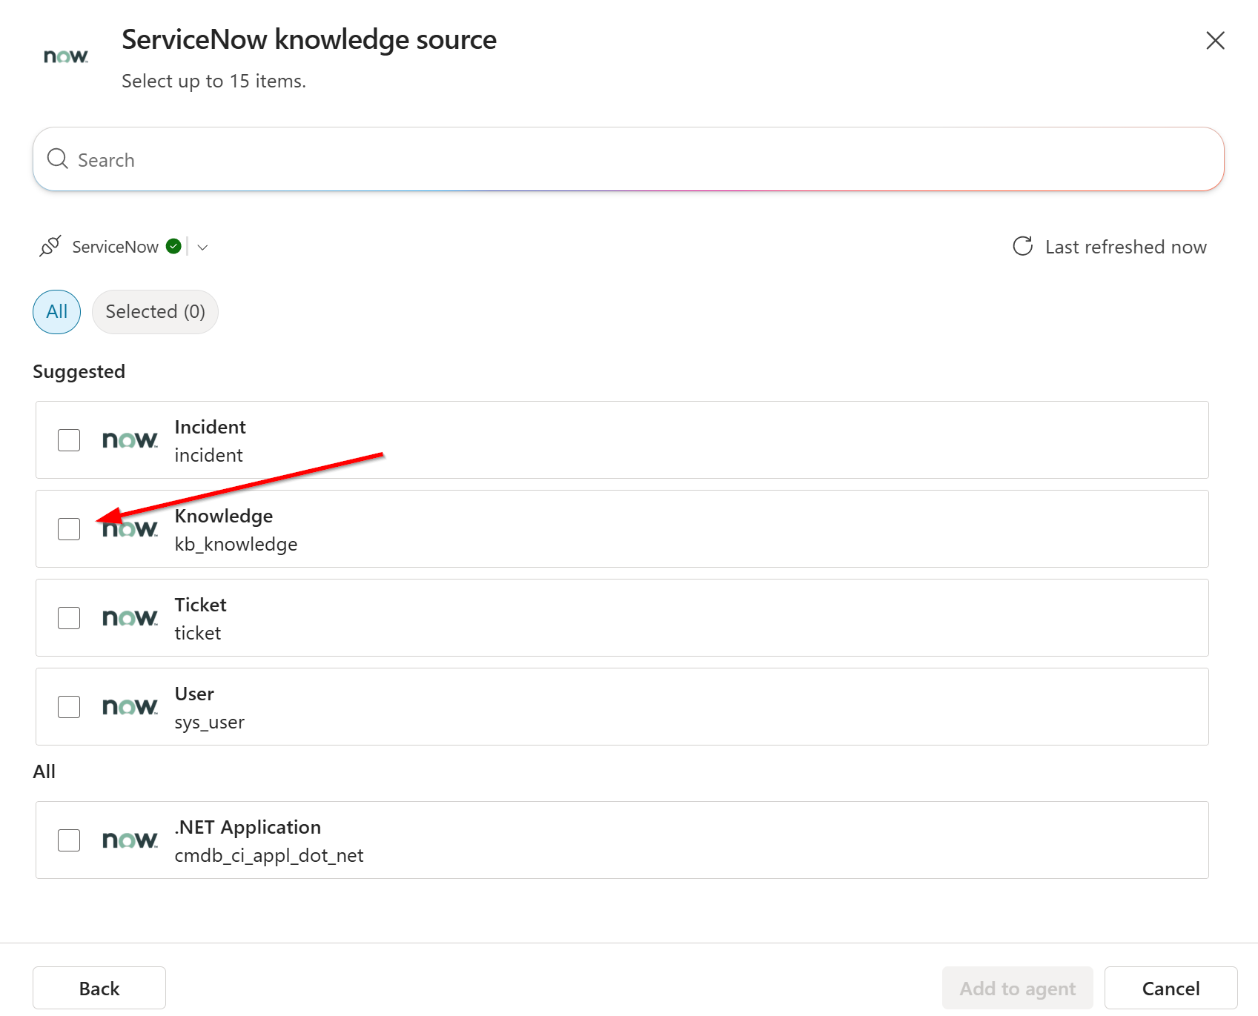
After a moment, the “Add to Agent” button will become available to click.
Once you select that you’ll be navigated back to the list of knowledge sources and you should see our new entry. The status will show in progress for some time. If it results in error state, test one of your questions to be sure the indexing has failed.
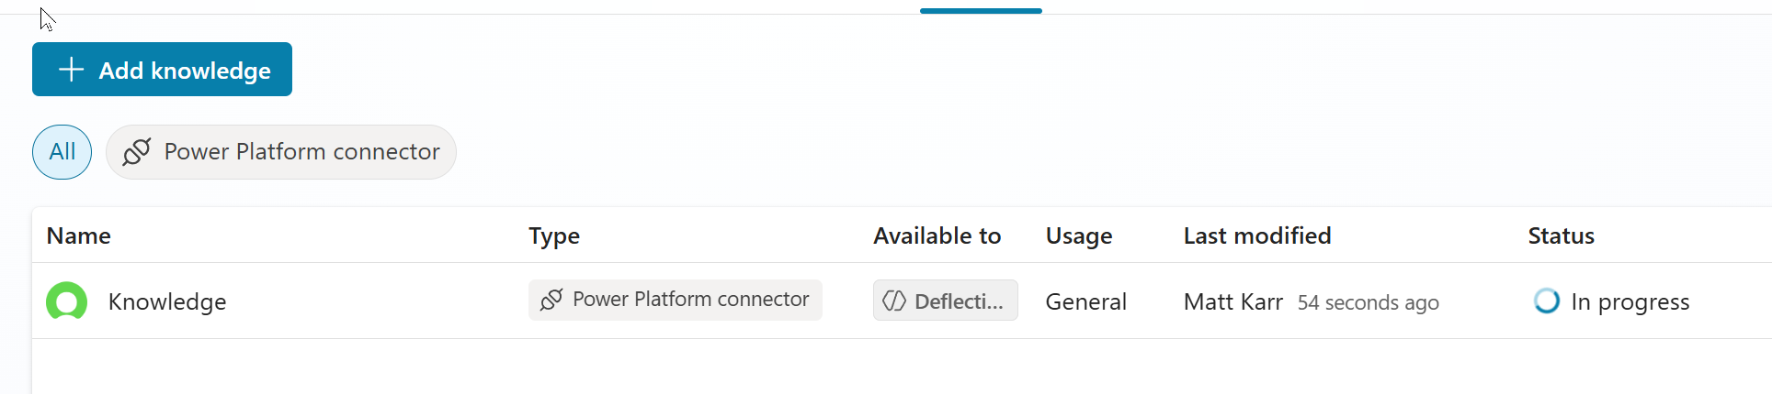
Click into the knowledge by selecting the name.
Expand the options and change the setting to only allow the knowledge to be called by topics
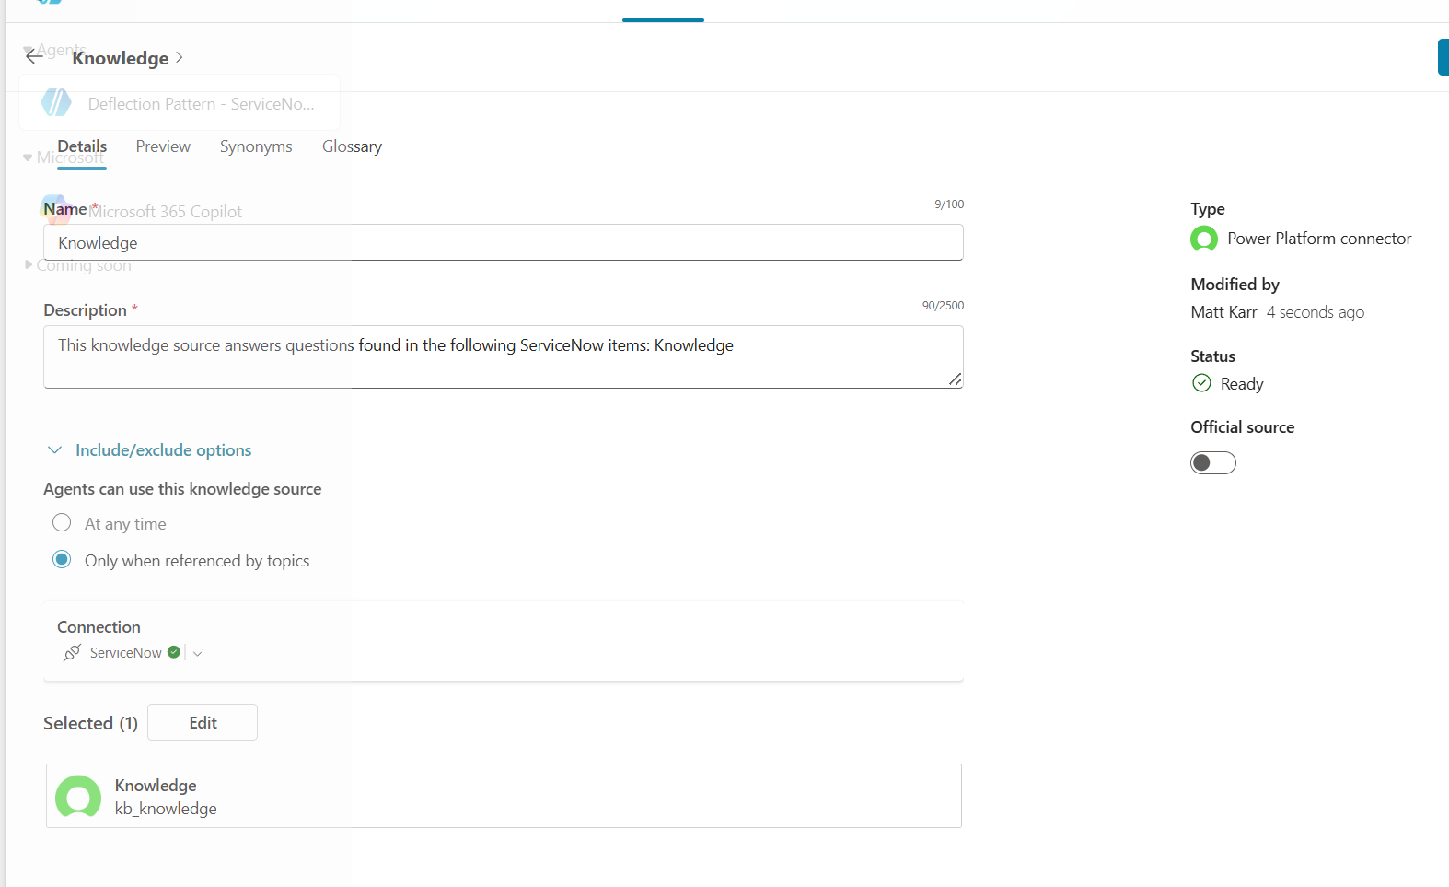

Tools
On the tools tab you will see 4 entries.
“Chit Chat” and “IT Query Rewrite” do not need configuration, but it’s a good idea to explore them to understand the functionality they bring to the agent.
We will need to validate the configuration for “Create Record” and “List Record”
Click on Create Record
In the details area, verify the ServiceNow connection is populated with a green checkmark
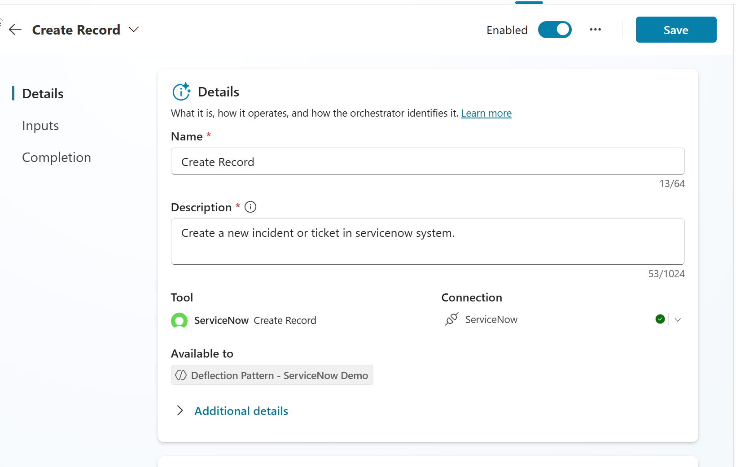

Click on Tools to return to the list, be sure to leave without saving if you made any changes.
Repeat the connection validation for list records.
Click Settings (top right), then select Connections from the left navigation.
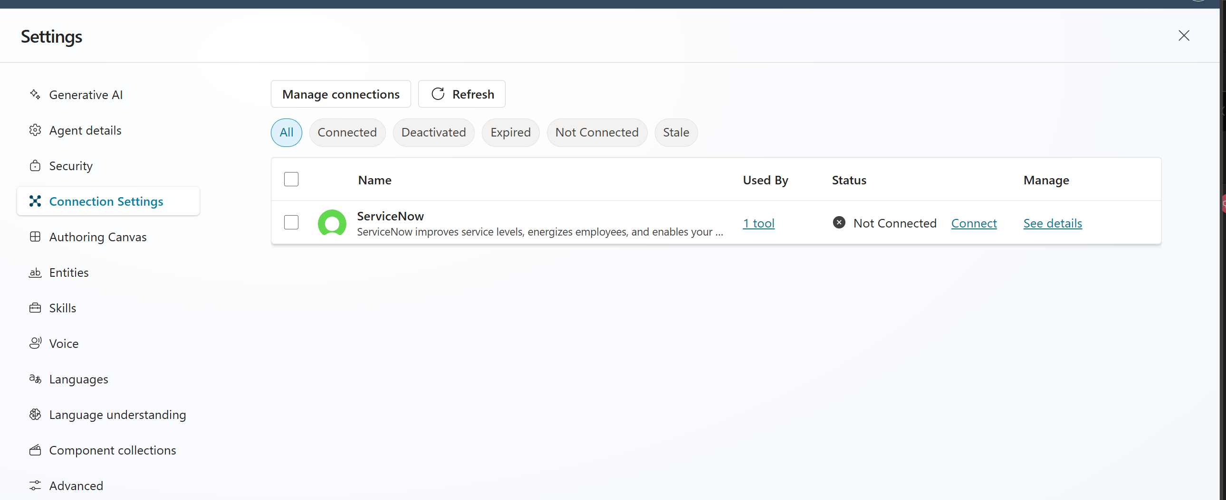
Verify the row shows Connected. Click connect if it does not.
Your established connection should auto select and you will see a green check.
Click Submit.
The entry should now show as connected
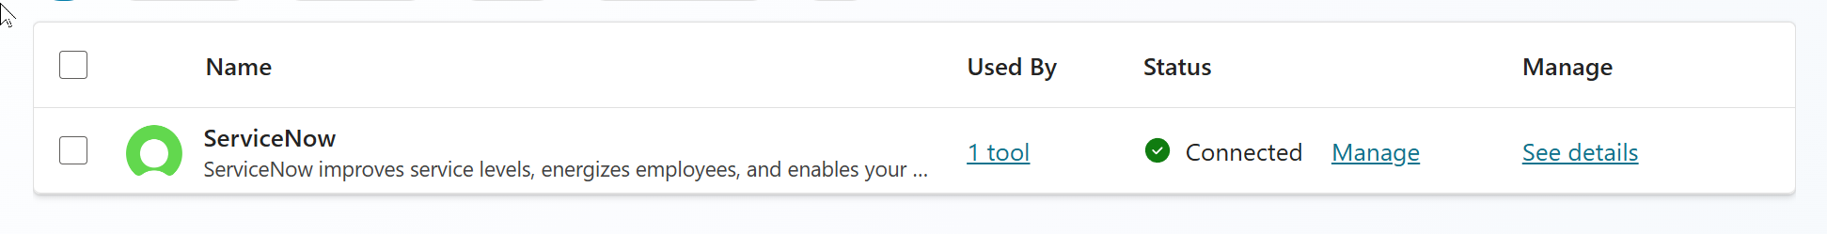

Close the settings by clicking the x in the top right corner beneath the profile icon

Topics
Select the topics tab
You will see an error next to the topic “Knowledge Assist.” Select the topic by clicking the name.
After a few knowledge tests, you may want to modify this topic to reduce the messages sent. First would be to remove the message node beneath “Create search query.” The goal of this step is to demo the query rewriting functionality.
Scroll down to the “Create generative answer” node and select the 3 dots in the top corner and select properties.
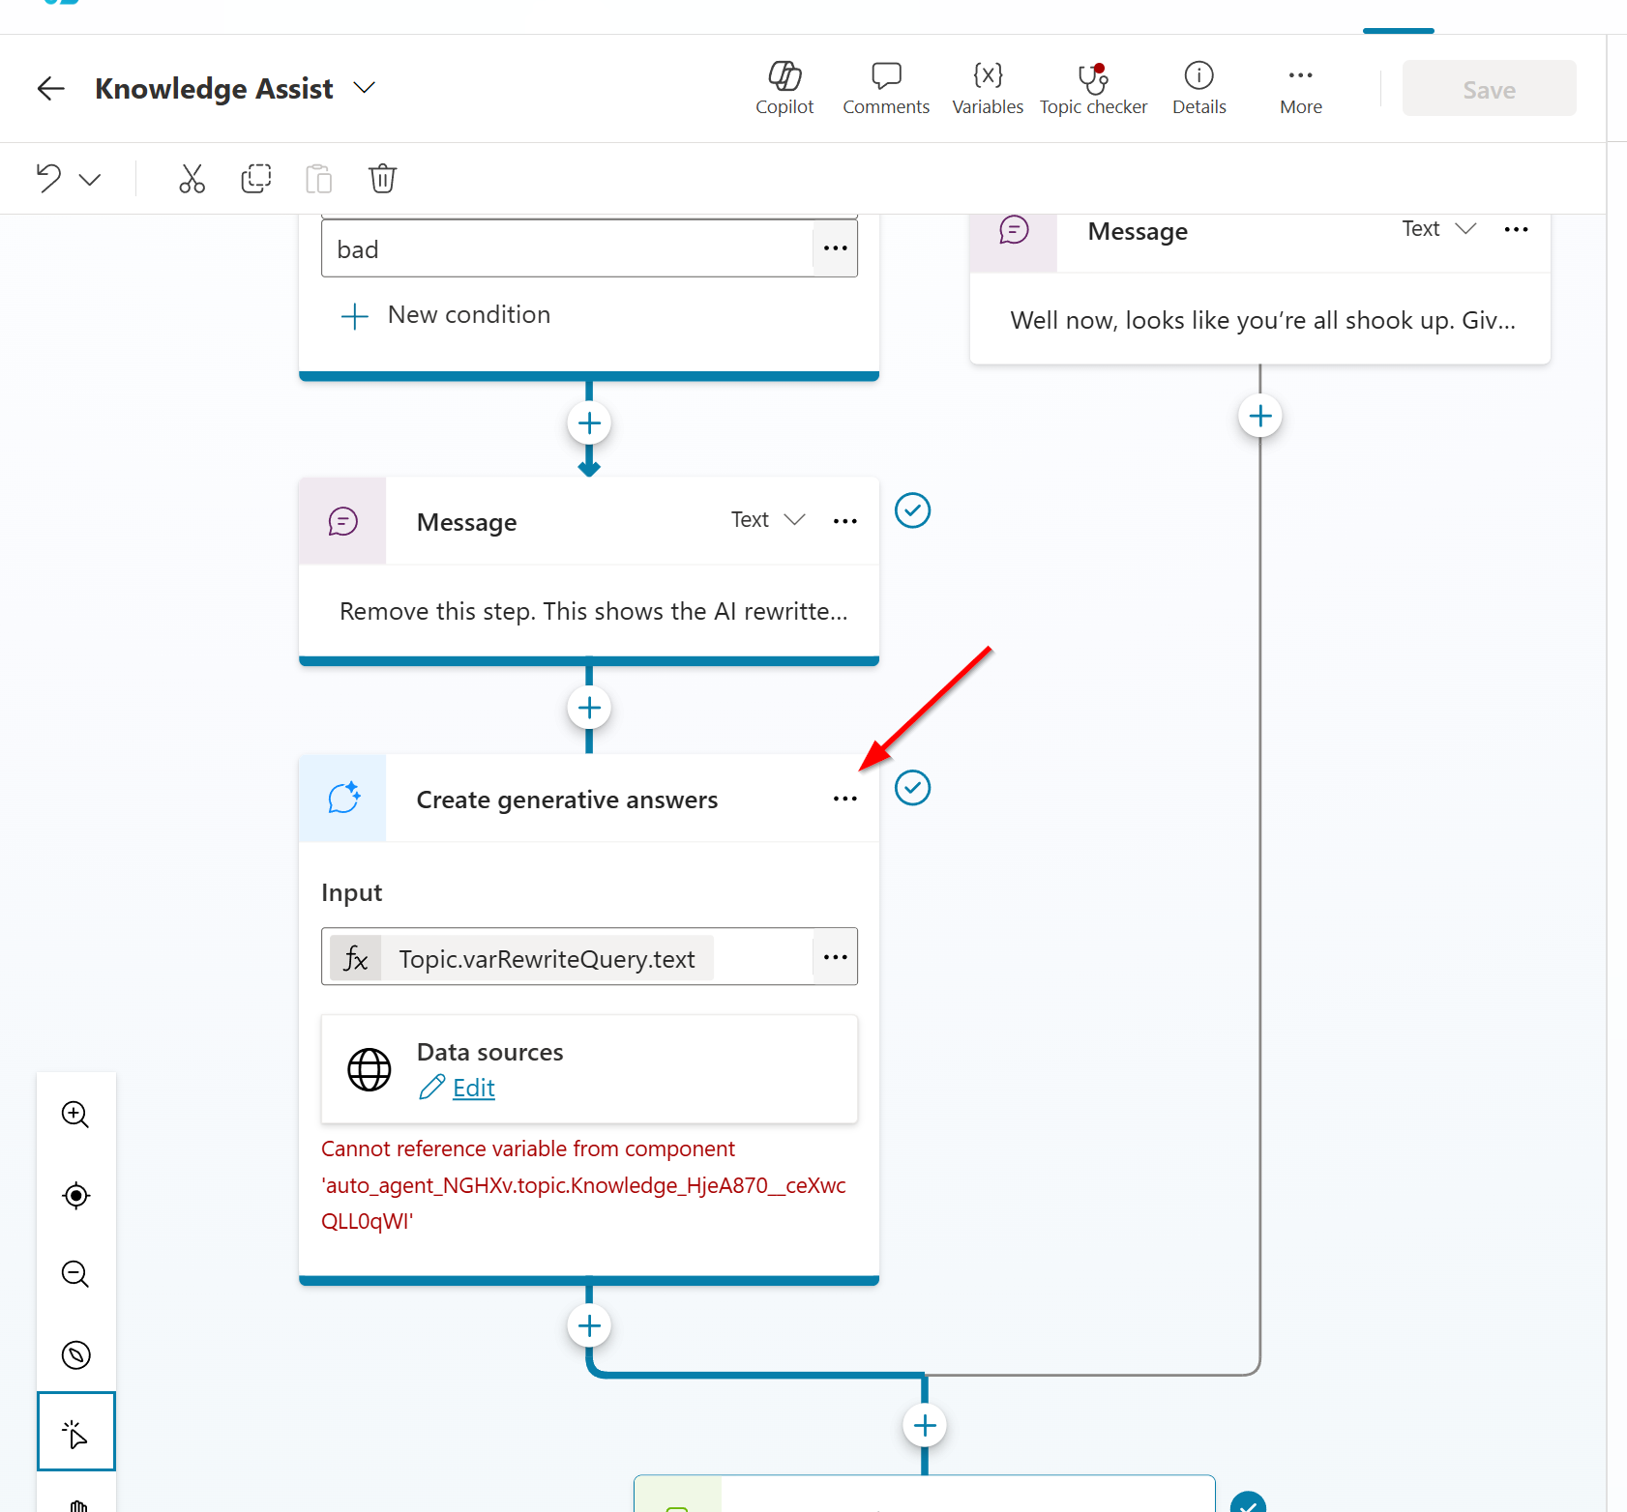
In the properties fly out, select the checkbox next to Knowledge listed under sources.
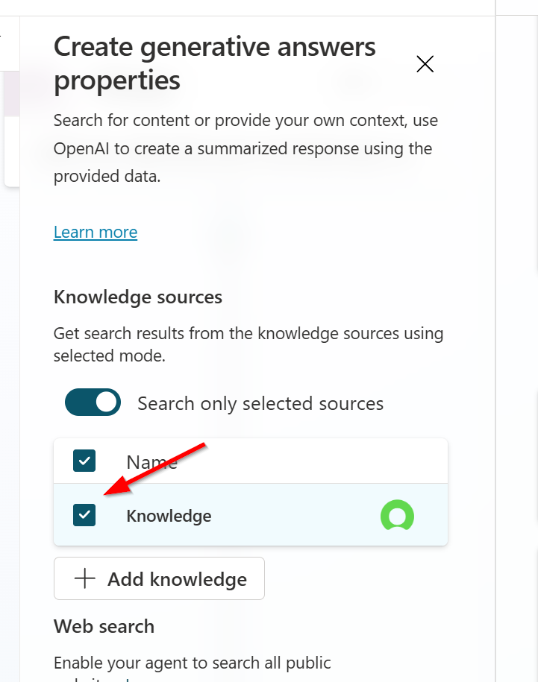

Scroll down. You’ll see a row under latency message that says “Just a sec.” Feel free to modify this to match the tone you want established in your agent.
Click the blue save button near the top of the screen above the properties fly out

Conversation Start
From the System topic list select Conversation Start
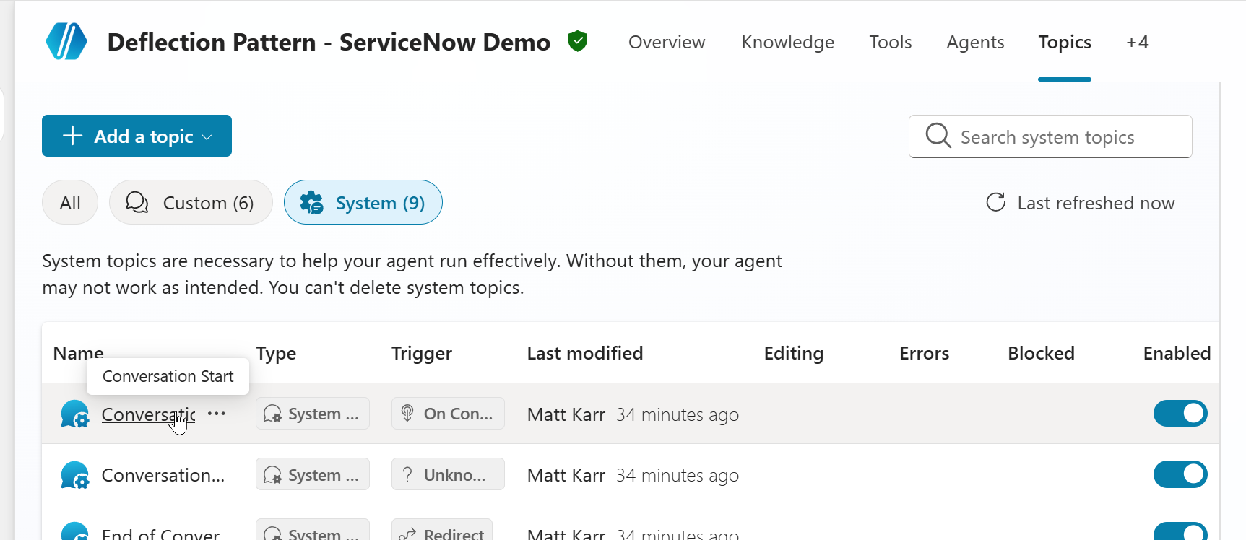
In the message node modify the text to match the tone and persona of your agent. Hint Copilot is good at helping to generate this text.

Go back to the knowledge tab and verify that the status of the source has switched to Ready.

You are now ready to test your agent.

Validation / Test Plan
Use the checks below to confirm the import, connections, knowledge indexing, and tools are working end-to-end.
- Connection health: In Power Platform, confirm the ServiceNow connection shows Connected.
- Solution import: In Solutions, confirm the imported solution appears and opens without errors.
- Knowledge indexing: In Copilot Studio > Knowledge, confirm the ServiceNow knowledge source status is Ready.
- Knowledge Q&A test: In the agent test chat, ask: “I need help to setup my email signature”. Confirm the agent responds with guidance sourced from knowledge (not a generic answer) and does not error.
- Tool test (Create Record): In the agent test chat, request creation of an incident (for example: “Create an incident: Email signature setup help”). Confirm the agent completes without connection errors.
- Tool test (List Record): Ask the agent to list recent incidents (for example: “List my most recent incidents”). Confirm you receive results (or a clear ‘none found’) without errors.
